European Powered Flying Union
-----------------------------------------------------------------------------------------------------------------------------------------------------------------------------
155, avenue de Wagram - 75017 Paris
kuno@aon.at / +43 664 44 11 246


REGISTRATION
for the
Annual General Assembly 2026

Date: 11 APR 2026 Place: JUFA Hotel Wien City ***
13.00 – 17.00 Mautner Markhof Gasse 50
1110 Wien

Name of participant |  | ARR at VIE |  | DEP from VIE
 |  | Date | Time | Date | Time
DELEGATE
ALTERNATE
DELEGATE
OBSERVER

Nō. of rooms incl. breakfast | Single ( 125 € / night ) | Double ( 145 € / night )
DELEGATE
ALTERNATE DELEGATE
OBSERVER

Nō. of MEALS  Nō. of SIGHTSEEING | Delegates and  Alternate Delegates | Observers and/or  Accompanying persons
Dinner ( at JUFA Hotel )  FRI, 10 APR at 19.00 | ¹⁾ | ¹⁾
Lunch ( at JUFA Hotel )  SAT, 11 APR at 12.00 | ¹⁾ | ¹⁾
Dinner ( Downtown )  SAT, 12 APR at 19.00 | ²⁾ | ²⁾
Sightseeing ( Vienna )  SUN, 13 APR from 10.00 to 14.00 | ³⁾ | ³⁾

¹⁾ On behalf of the EPFU ²⁾ Sponsored by the Austrian Aero-Club ³⁾ Only organized if we receive enough interest

Date | Signature



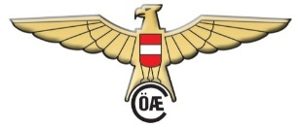
Please reply latest by
20th of February 2026

HOW TO REACH THE LOCATION ?


If you and/or your spouse will have time to explore the city by public transport, you can buy tickets at all available ticket machines, or via internet. Just follow this link and choose a 24 hours ticket ( 9,70 € ) and select a valid from date & time.

THEN YOU ARE FREE TO USE ALL PUBLIC TRANSFER IN THE CITY
(S-BAHN, UNDERGROUND, TRAM AND BUS) FOR 24 HOURS !

After leaving the baggage claim area at the airport, turn right and walk down the ramp to the train station, where you can buy a ticket to “ WIEN ENKPLATZ “ for less than 5 € at the ticket machines, because the airport isn’t included IN THE the city zone of a 24 hours ticket.


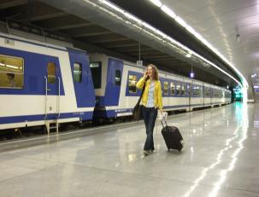

If you choose ÖBB take either a “ REX 7 “ or a “ S 7 “ for 5,2 € and get off the train after app. 25’ at
“ WIEN MITTE / LANDSTRASSE “.

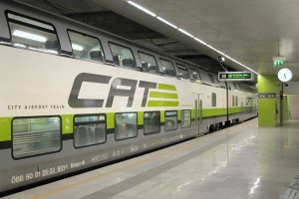


Alternatively you can take the more expensive CAT (14,9 € one way; 24,9 € return ticket) which leaves every 30’ and bring you in 16’ non-stop to
“ WIEN MITTE / LANDSTRASSE “.

RMK/ Don’t take any direct train to WIEN HAUPTBAHNHOF.

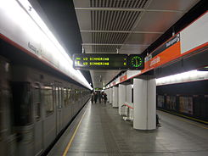

At WIEN MITTE / LANDSTRASSE follow the signs and join the underground line
“ U3 SIMMERING “.

Leave the underground at
“ ENKPLATZ “.

Follow the red line on following map, which brings you to the entrance of “ Hotel JUFA “:
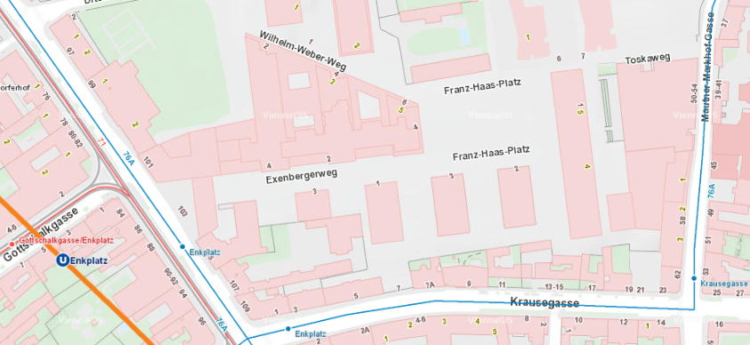



IF YOU NEED ASSISTANCE,
PLEASE CALL THE TREASURER
+43 / 664 / 44 11 246

