EPFU News Flash No. 146, September 2025

Dear Friends  No big or shocking news that I am aware of. AVGAS 100 LL remains available till 2032. You can read about its availability extension period here:  https://pilot-hub.com/en/remaining-avgas-100ll-remains-permissible-in-europe-until-2032-reach-committee-provides-clarity-for-general-aviation/  Martin also was very active. He found details about an FAA initiative announcing improvements for recreational aviation activities. A welcomed course of action. Maybe this will have an impact on Europe’s aviation as well in the future. This is the “link”:  https://www.faa.gov/newsroom/us-transportation-secretary-sean-p-duffy-announces-improvements-recreational-aviation |  |  |  |  |   “My” Airbus A350 overtakes a British Airways Boeing 787at FL380. A special view, reserved for co-pilots.
Another item highlights the importance of controller<<<>>>cockpit communication, shows how things can go wrong, if controllers and pilots do not fully understand each other. This is the “link”:

https://airlive.net/aeronautics/2025/07/11/when-french-atc-issues-an-alert-after-mistaking-lavatory-problem-for-pilot-emergency/

All this adds to René’s usual contribution covering various topics of interest to our community. Enjoy this News Flash, stay safe!

Your President

EASA publishes Annual Safety Review 2025  26/8/2025 The European Union Aviation Safety Agency (EASA) has published the Annual Safety Review (ASR) 2025, which provides a comprehensive analysis of aviation safety in 2024 and compares it with trends from the past decade. Here follow the Highlights from the 2024 data, presented by the Agency:  - Traffic levels: European air traffic continued its strong recovery with over 7.7 million flights operated by 623 air operator certificate (AOC) holders.  - Global context: There were 14 fatal accidents worldwide in 2024 with 304 fatalities. These statistics are both in line with the 10-year average.  - Commercial air transport (CAT) — Aeroplanes: Europe saw 3 fatal accidents leading to 3 fatalities.  - General Aviation: There were a total of 27 fatal accidents in Europe, leading to 44 fatalities. This represents a slight decrease compared with recent years. |  |  |  |  | 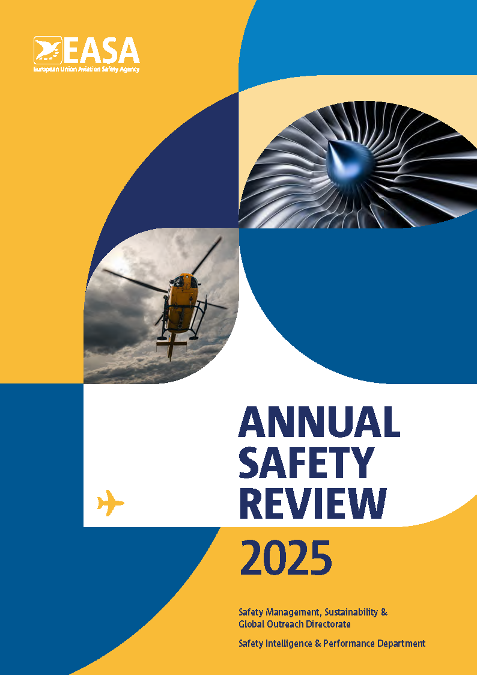
- Rotorcraft: This domain saw 7 fatal accidents with 14 fatalities across Europe. This is consistent with historical patterns in the Rotorcraft domain.
- Sailplanes: There were 10 fatal accidents involving Sailplanes with 12 fatalities. This is the lowest level of annual fatalities ever recorded in this domain of aviation.
- Drones / Unmanned aircraft systems (UAS): The reporting of occurrences continues to increase, underlining the growing importance of safe integration into the European airspace. This is a key part of EASA’s U-Space implementation.

For the full documentation please go to

https://www.easa.europa.eu/en/newsroom-and-events/news/easa-publishes-annual-safety-review-2025?utm_campaign=d-20250827&utm_term=pro&mtm_source=notifications&mtm_medium=email&utm_content=title&mtm_placement=content&mtm_group=easa_news

Electrifly-In, Bern Airport (LSZB), Bundesbasis
13 – 14/9/2025

Newsdays on innovative propulsion technologies for aircraft with fly-in, symposium, keynotes, expo and trial flights.

For all details please go to

https://electrifly-in.ch/en/

For the programme please go to

https://electrifly-in.ch/en/programme/

2025 ANAC Technical Standard Order (TSO) Workshop, 17 and 18/9/2025, Repetition

On-site event at the Hotel Golden Tulip, Av. São João, 2200 - Jardim das Colinas, São José dos Campos - SP, 12242-000, Brazil

The TSO Workshop is organised in turn by ANAC/EASA/FAA/TCCA. This year ANAC is hosting the 20th TSO
Workshop in Sao Jose dos Campos, Brazil
Not just around the corner, to be held on 17 and 18/9/2025. For all details:

https://www.easa.europa.eu/en/newsroom-and-events/events/2025-anac-technical-standard-order-tsoworkshop

EASA publishes new revision of Easy Access Rules for Standardised European Rules of the Air (SERA)  27/8/2025 Easy Access Rules for Standardised European Rules of the Air (SERA) (Regulation (EU) No 923/2012). This Revision from August 2025 of the Easy Access Rules for Standardised European Rules of the Air (EAR for SERA) incorporates the following: |  |  |  |  |  |  |  |  | 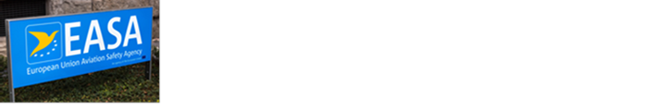
- the removal of the special formatting from the rules applicable from 1 May 2025 as well as the deletion of their outdated counterparts that were applicable until 30 April 2025; and
- ED Decision 2025/012/R issuing new and amending existing acceptable means of compliance and guidance material (AMC & GM) to enable innovative air mobility with manned aircraft that have a capability for vertical take-off and landing (VTOL).

This address brings you to the document:

https://www.easa.europa.eu/en/newsroom-and-events/news/easa-publishes-new-revision-easy-access-rules-standardised-european-rules

Terms of Reference (ToR), Notices of Proposed Amendments (NPA), Comment Response Documents (CRD), Opinions, Agency Decisions, and Public Consultations published between 1/8/2025 and 31/8/2025. Titles or text parts in bold characters means that the texts are at least partially important for our community:

ToR:

11/08/2025 ToR RMT.0763 Alignment of common requirements for ATM/ANS providers with SES 2+. Not directly for our community. Interested parties may go to

https://www.easa.europa.eu/en/document-library/terms-of-reference-and-rulemaking-group-compositions/tor-rmt0763

Focused Consultation: None.

Public Consultations by EASA: None.

Notices of Proposed Amendment:

NPA 2025-03 Environmental protection requirements for products not covered by ICAO Annex 16 | Noise requirements for vertical take-off and landing (VTOL)-capable aircraft (VCA) (, published 22/8/2025 (RMT.0733). This NPA comes in three parts, A, B, and C. It proposes:

- to create a delegated act to include detailed noise requirements applicable to (VCA) and a decision on the related acceptable means of compliance (AMC) and guidance material (GM); and
- to amend Annex I (Part 21) to Commission Regulation (EU) No 748/2012 for consistent implementation of the proposed new delegated act, and the related AMC and GM.

The proposed regulatory material is expected:

- to ensure that new VCA are designed to minimise noise;
- to provide a level playing field for manufacturers;
- to provide certified noise levels for reference to the competent authorities responsible for land-use planning and for granting VCA operational authorisations;
- and to maintain a high level of environmental protection in Europe.

Comment period ends on 25/11/2025. Please comment individually.

For all three parts of this NPA please go to

https://www.easa.europa.eu/en/document-library/notices-of-proposed-amendment/npa-2025-03

Repetition
NPA 2025-02(A) Alignment of Regulation (EU) No 748/2012 and Regulation
(EU) No 1321/2014 with Regulation (EU) 2018/1139 Certification and continuing airworthiness of noninstalled equipment (RMT.0727, Subtask 3)

The Agency writes: “This NPA puts forward amendments to Regulation (EU) No 748/2012 (the Initial Airworthiness Regulation) and Regulation (EU) No 1321/2014 (the Continuing Airworthiness Regulation), together with their associated acceptable means of compliance (AMC) and guidance material (GM), in order to align them with Regulation (EU) 2018/1139 (the Basic Regulation) in respect of the certification and continuing airworthiness of noninstalled equipment (NIE).

The aim of the proposed regulatory material is to clarify the processes applicable for the initial certification and continuing airworthiness of NIE. This will allow the stakeholders concerned to apply to the maximum extent possible the existing certification and continuing airworthiness processes, thus reaping the full benefits of applying well-established industry processes. When and if relevant, in order to increase efficiency, simplifications are proposed with regard to the exemption from the requirement for capability demonstration for the production of NIE that consists of software applications only to allow for adaptations to the specificities of NIE.”

Description of the issue by the Agency, first paragraph: “EASA currently lacks a regulatory means to approve NIE since the concept of NIE is not currently reflected in Part 21 of Regulation (EU) No 748/2012 nor is it reflected in Regulation (EU) No 1321/2014, which only refers to the continuing airworthiness of components installed on aircraft. This means that EASA does not have a formal process to approve NIE in case there is a need to address a safety issue with a particular article that is carried on board the aircraft by the operator. In addition, the current regulations do not include any provisions regarding how and by whom such NIE should be maintained and controlled on board the aircraft.”

NPA 2025-02 comes in seven parts. For all seven chapters please go to

https://www.easa.europa.eu/en/document-library/notices-of-proposed-amendment/npa-2025-02

NPA 2025-02(A) Alignment of Regulation (EU) No 748/2012 and Regulation (EU) No 1321/2014 with Regulation (EU) 2018/1139 (the Basic Regulation). Certification and continuing airworthiness of non-installed equipment (RMT.0727, Subtask 3), introduced above.

NPA 2025-02(B) Proposed amendments to Regulation (EU) No 748/2012, Initial Airworthiness

NPA 2025-02(C) Proposed amendments to Annex I (Part 21) to Regulation (EU) No 748/2012

NPA 2025-02(D) Proposed amendments to the AMC and GM to Annex I (Part 21) to Regulation (EU) No 748/2012
NPA 2025-02(E) Proposed amendments to Regulation (EU) No 1321/2014, Continuing Airworthiness

NPA 2025-02(F) Proposed amendments to the annexes to Regulation (EU) No 1321/2014
NPA 2025-02(G) Proposed amendments to the AMC and GM to Regulation (EU) No 1321/2014 and its annexes

Comment period ends on 7/10/2025. Please comment individually by using the Agency’s CRT as expressed in chapter 1.2 of NPA 2025-02(A), mid-page 3/20. Part-21, Part-ML, Part-M, Part-66, Part-145, Part-CAMO, and Part-CAO are affected by NPA 2025-02.

Agency Decision:

13/08/2025 ED Decision 2025/016/R Implementation of the latest CAEP amendments to ICAO Annex 16 Volumes I, II and III – CAEP/12 | Awareness of Regulation (EU) 2015/640 provisions applicable to design approval holders. This Decision updates the Acceptable Means of Compliance (AMC) and Guidance Material (GM) to Annex I (Part 21) to Regulation (EU) No 748/2012 to support and clarify the application of the procedures for the environmental protection certification of products. Interested parties may go to

https://www.easa.europa.eu/en/document-library/agency-decisions/ed-decision-2025016r

Opinions: None.

Comment Response Documents: None.

EU Consultations: (“Have your say”): Repetition

The Commission would like to hear our views on the two proposals presented here:

COMMISSION DELEGATED REGULATION (EU) …/... of XXX laying down rules on the organisation and composition of the Board of Appeal of the European Aviation Safety Agency, and repealing Commission Regulation (EC) No 104/2004, and to the

ANNEXES to the COMMISSION DELEGATED REGULATION (EU) …/... supplementing Regulation (EU) 2018/1139 of the European Parliament and of the Council by laying down rules on the organisation and composition of the Board of Appeal of the European Union Aviation Safety Agency, on its members and on its procedure, and repealing Commission Regulation (EC) No 104/2004. For your comments please go to

https://ec.europa.eu/info/law/better-regulation/have-your-say/initiatives/14775-EASA-BoA-Delegated-Regulation_en

Comment period ends on 5/9/2025 already

The Commission would also like to read our views on this proposal:

Aviation – fitness check of EU airport legislation

The Commission is carrying out a fitness check of EU airport legislation to determine if it is still fit for purpose and delivering on its objectives. This fitness check will consider recent trends such as market consolidation, capacity challenges, labour shortages, increased competition from non-EU airlines/airports and the need to decarbonise. It will also assess the potential for simplification and burden reduction, especially should any inconsistencies or synergies be identified. The consultation period ends on 28/10/2025. Interested parties may go to

https://ec.europa.eu/info/law/better-regulation/have-your-say/initiatives/14193-Aviation-fitness-check-of-EU-airport-legislation_en

EU Regulations:

Commission Delegated Regulation (EU) 2025/1044 of 23 May 2025 supplementing Regulation (EU) 2018/1139 of the European Parliament and of the Council with detailed rules and procedures on the acceptance of air traffic controller licences and certificates issued by third countries. Published 6/8/2025. After reading the published text your Technical Officer is not convinced by the measures proposed… If interested, please go to

https://eur-lex.europa.eu/eli/reg_del/2025/1044/oj/eng

Murphy’s Law COMPLETE, compiled by Arthur Bloch

On page 84 we find Blaauw’s Law: “Established technology tends to persist in spite of new technology.”

European Powered Flying Union  Best wishes, kind regards,  René Meier, Technical Officer  1/9/2025  CH-2540 Grenchen, Switzerland  Mobile +41 79 333 63 93  rene.meier2540@bluewin.ch |  |  |  | Distribution:  EPFU Members  EPFU Friends  Individual subscribers

